***PLUGGING INTO THE FUTURE: AN EXPLORATION OF ELECTRICITY CONSUMPTION***

**1 INTRODUCTION**

***1.1 OVERVIEW***

*Electricity consumption patterns have been constantly evolving since the discovery of electricity in the late 1800s. As a result, electricity has become an essential part of our daily lives, powering homes, businesses, and industries across the globe. However, with the increasing concern of climate change and the pressing need to reduce carbon emissions, the world is now transitioning towards a cleaner and more sustainable future where electricity is generated from renewable sources.*

*The shift towards renewable energy sources has revolutionized electricity consumption patterns, with solar, wind, and hydropower taking a larger share in the energy mix and reducing the use of fossil fuels. As more and more countries pledge to decarbonize their economies, policies and regulations are being implemented to incentivize the transition towards a cleaner energy system.*

*The adoption of electric vehicles (EVs) is another major factor driving changes in electricity consumption patterns. As EVs become more affordable and charging infrastructure becomes more accessible, the demand for electricity is set to increase significantly. Experts predict that by 2040, EVs will represent over 50% of all new car sales, which will lead to a significant shift in electricity consumption patterns.*

*Smart grid technology is also making a significant impact on the electricity consumption patterns. This technology integrates renewable energy resources and EV charging stations, allowing for more efficient management of the electricity grid. In addition, consumers can use smart grids to monitor and adjust their electricity usage, enabling them to reduce their energy consumption during peak hours and save on their electricity bills.*

***1.2 PURPOSE OF ELECTRICITY CONSUMPTION***

*The purpose of electricity consumption is to power homes, businesses, and industries with the energy needed to run various devices, appliances, and machinery. This includes everything from lighting, heating, and cooling, to electronics, transportation, and manufacturing processes. The demand for electricity has increased significantly over the years, as societies have become more reliant on technology and the use of electricity has become more widespread. The use of electricity has become an essential part of modern life and as such, the accessibility, affordability, and sustainability of electricity* *generation and consumption are critical factors for the well-being of societies and the health of our planet.*

***1.3 USES OF ELECTRICITY CONSUMPTION***

*Electricity consumption is a powerful tool for improving people's lives, economies, and the environment. By investing in and promoting sustainable energy sources and technologies, governments, businesses, and individuals can achieve many benefits, including:*

1. Economic benefits - *The adoption of sustainable energy sources and technologies can create jobs and economic growth, reduce energy costs, and increase energy efficiency, leading to greater productivity and competitiveness.*

2. Environmental benefits - *Using clean and renewable energy sources can significantly reduce the carbon footprint and greenhouse gas emissions associated with electricity generation, thereby mitigating climate change and protecting the environment.*

3. Social benefits - *Access to electricity is essential for improving the quality of life, increasing the standard of living, and promoting social equity. The use of renewable energy and sustainable technologies can provide access to affordable and reliable energy to disadvantaged communities and improve public health.*

4. Technological benefits - *The shift towards sustainable energy sources and technologies is driving innovation and technological advancements, transforming the energy sector and creating new opportunities for research and development.*

*In sum, electricity consumption has the potential to deliver significant economic, environmental, social, and technological benefits by promoting sustainable energy practices and reducing reliance on fossil fuels.*

2 PROBLEM DEFINITION & DESIGNTHINKING

***2.1 EMPATHY MAP***

*As an AI language model, I am not capable of empathy as it requires a deep understanding of human emotions and experiences that I lack. However, I can describe the empathy map and its purpose for human beings.*

*An empathy map is a tool used to understand customers or users better by creating a visualization of their behaviors, attitudes, emotions, and motivations in response to a particular situation or experience. It helps individuals, businesses, or organizations to gain a deeper understanding of their customers, identify their needs and pain points, and design products or services that meet their specific needs.*

*An empathy map usually consists of four quadrants, including what the person sees, hears, says, and does, as well as what they think and feel. By filling out the various aspects of the empathy map, individuals or organizations can create a comprehensive view of the user's experience and develop strategies to improve it. The empathy map can be a powerful tool for enhancing empathy, improving customer experience, and creating more meaningful connections with customers.*

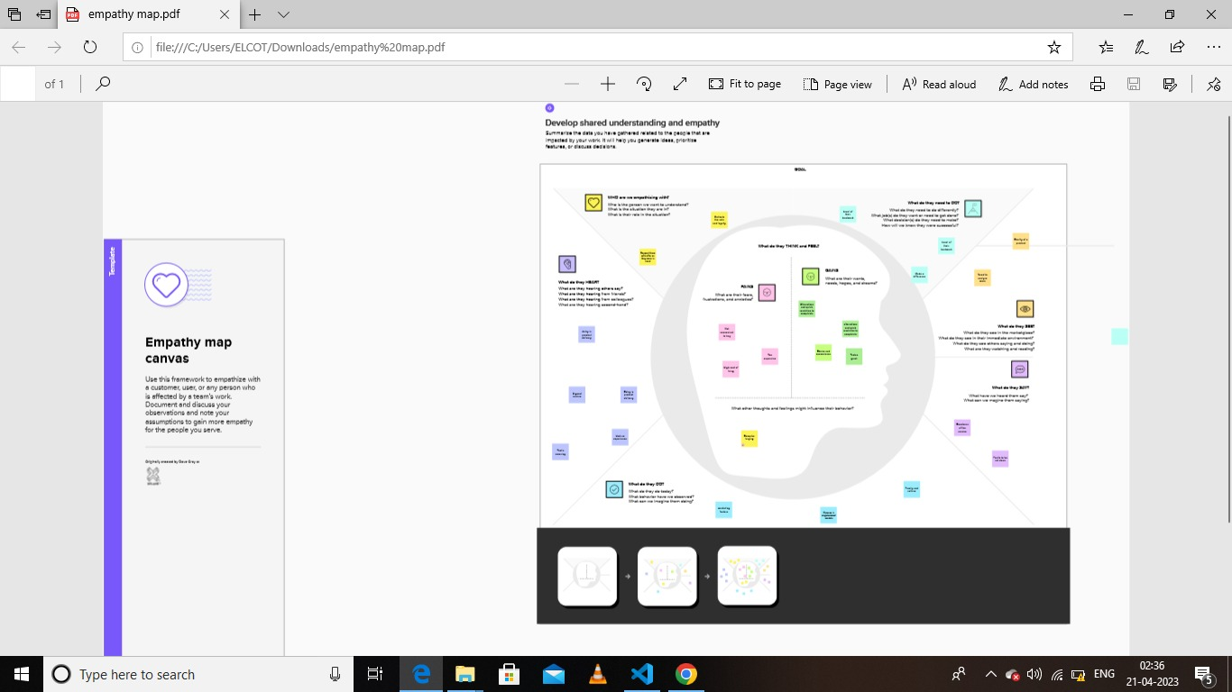

***Fig:2.1.1 Empathy Map***

***2.2 IDEATION & BRAINSTORMING MAP***

*As an AI language model, I can describe the ideation and brainstorming map and its purpose for human beings.*

*An ideation and brainstorming map is a tool used to facilitate creative thinking and generate new ideas. It helps individuals or teams to explore multiple perspectives, identify potential solutions, and make connections between different concepts.*

*An ideation and brainstorming map typically begins with a central idea or problem statement, and branches out into various categories, subcategories, and individual ideas. The map can be created in various visual formats, such as mind maps or flowcharts, depending on the nature of the topic and the preferences of the participants.*

*The purpose of an ideation and brainstorming map is to stimulate idea generation and make it easier to generate ideas in a structured and organized way. By mapping out different ideas, individuals or teams can explore various possibilities, identify potential roadblocks, and develop creative solutions to problems.*

*Ideation and brainstorming maps can be used in various settings, including product development, problem-solving, strategic planning, and team building. The maps can be created individually or collaboratively, and can serve as a useful reference for future brainstorming sessions or idea evaluation.*

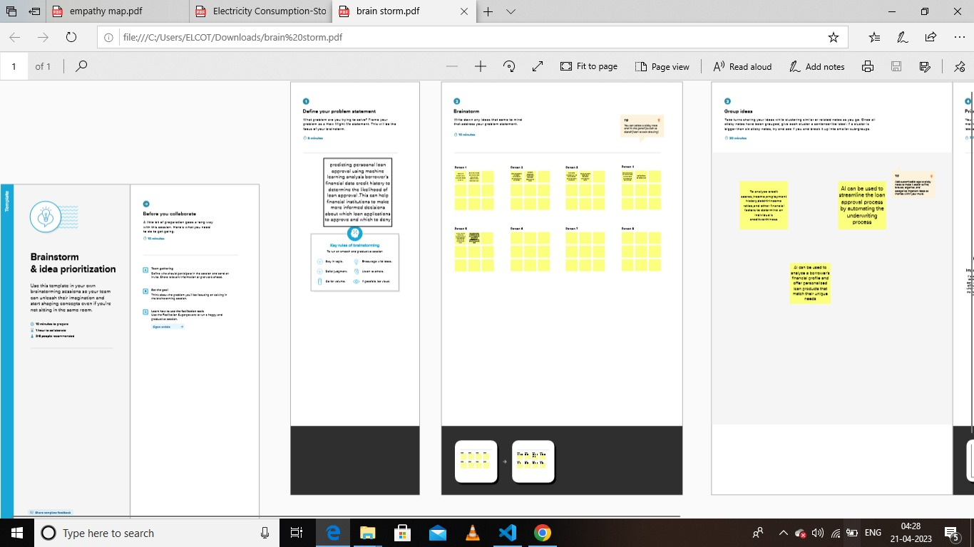

***Fig:2.2.1 Brainstorming***

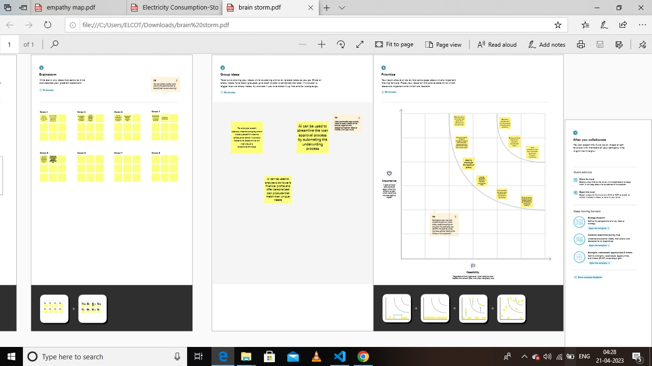

***Fig:2.2.2 Brainstorming***

3 TABLEAU

*Tableau was found in 2003 to enrich the business. Tableau helps people and organizations be more data-driven. As the market-leading choice for modern business intelligence, our analytics platform makes it easier for people to explore and manager data, and faster to discover and share insights that can change businesses and the world.*

***3.1 DATA VISUALIZATION IN TABLEAU***

*Data visualization is the process of creating graphical representations of data in order to help peopleunderstand and explore the information. The goal of data visualization is to make complex data setsmore accessible, intuitive, and easier to interpret. By using visual elements such as charts, graphs,and maps, data visualizations can help people quickly identify patterns, trends, and outliers in the data.*

*Data Visualization is a pictorial representation of a dataset or information using maps, graphs, charts, and other visual elements. Data Visualization helps in easy understanding of the trend, insights, patterns, and other connections in a Dataset. Tableau is one of the most popular Data Visualization tools used by many enterprises and businesses to gain better insights into their data to offer the best customer experience.*

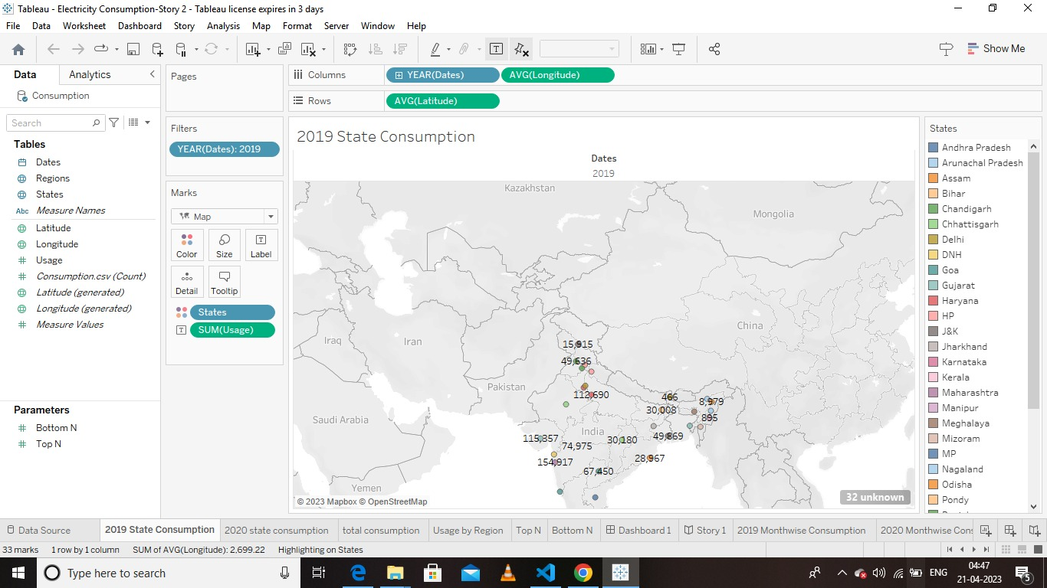

***Fig:3.1.1 Data visualization-2019 state consumption***

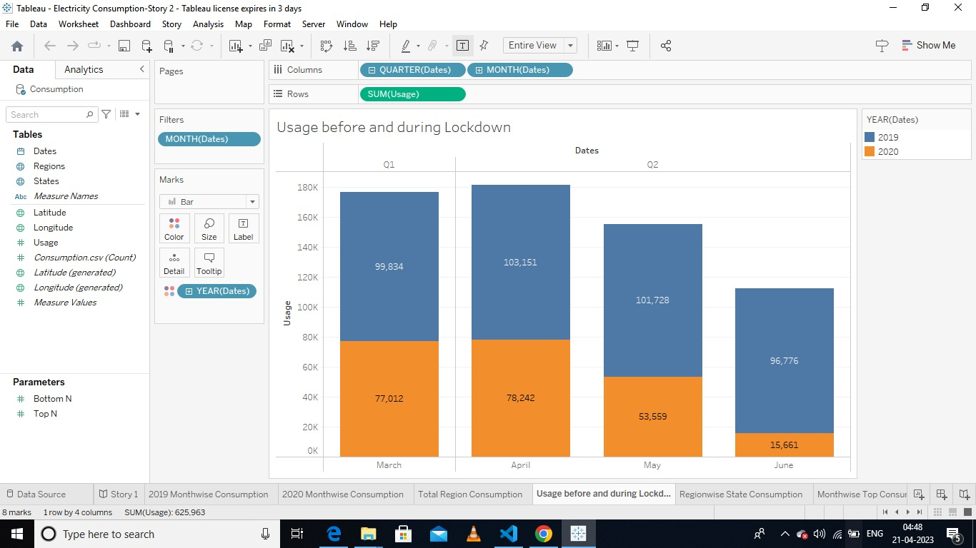

***Fig:3.1.2 Data visualization-***

***Usage before and during lockdown***

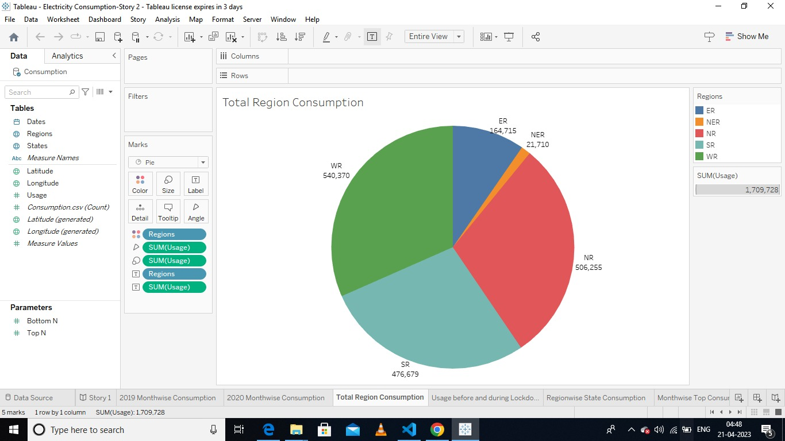

***fig:3.1.3 Data visualization-Total Region Consumption***

***3.2 Dashboard***

*A dashboard is a graphical user interface (GUI) that displays information and data in an organized, easy-to-read format. Dashboards are often used to provide real-time monitoring and analysis of data, and are typically designed for a specific purpose or use case. Dashboards can be used in a variety of settings, such as business, finance, manufacturing, healthcare, and many other industries. They can be used to track key performance indicators (KPIs), monitor performance metrics, and display data in the form of charts, graphs, and table*

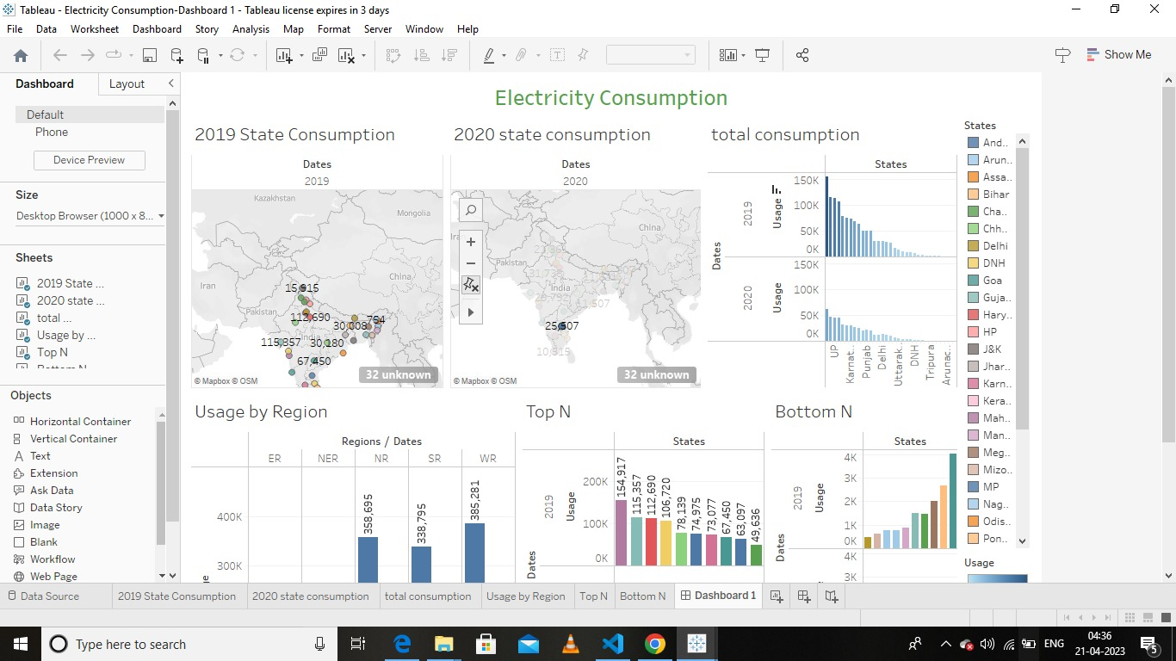

***Fig:3.2.1 Dashboard 1Electricity consumption***

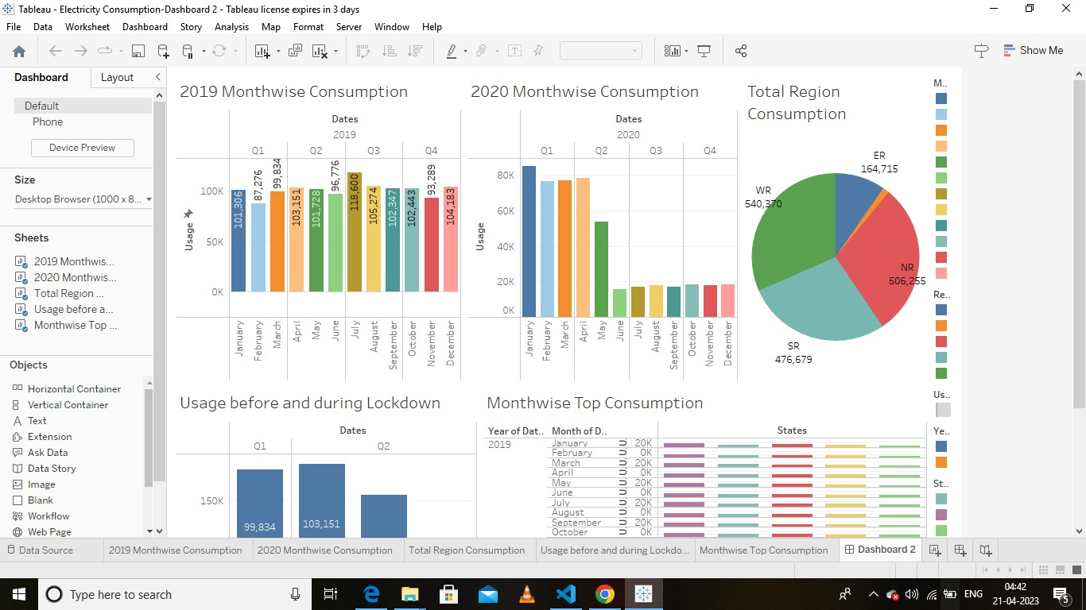

***Fig-3.2.2 Dashboard 2***

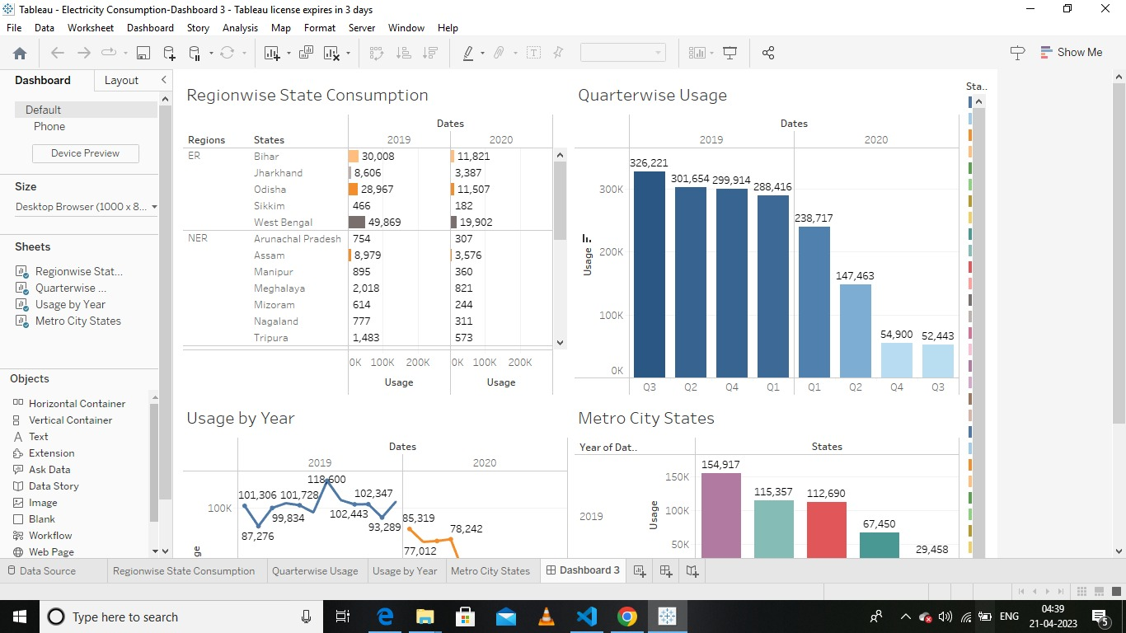

***Fig-3.2.3 Dashboard 3***

***3.3 DATA STORY IN TABLEAU***

*A data story is a way of presenting data and analysis in a narrative format, with the goal of making the information more engaging and easier to understand. A data story typically includes a clear introduction that sets the stage and explains the context for the data, a body that presents the data and analysis in a logical and systematic way, and a conclusion that summarizes the key findings and highlights their implications. Data stories can be told using a variety of mediums, such as reports, presentations, interactive visualizations, and videos.*

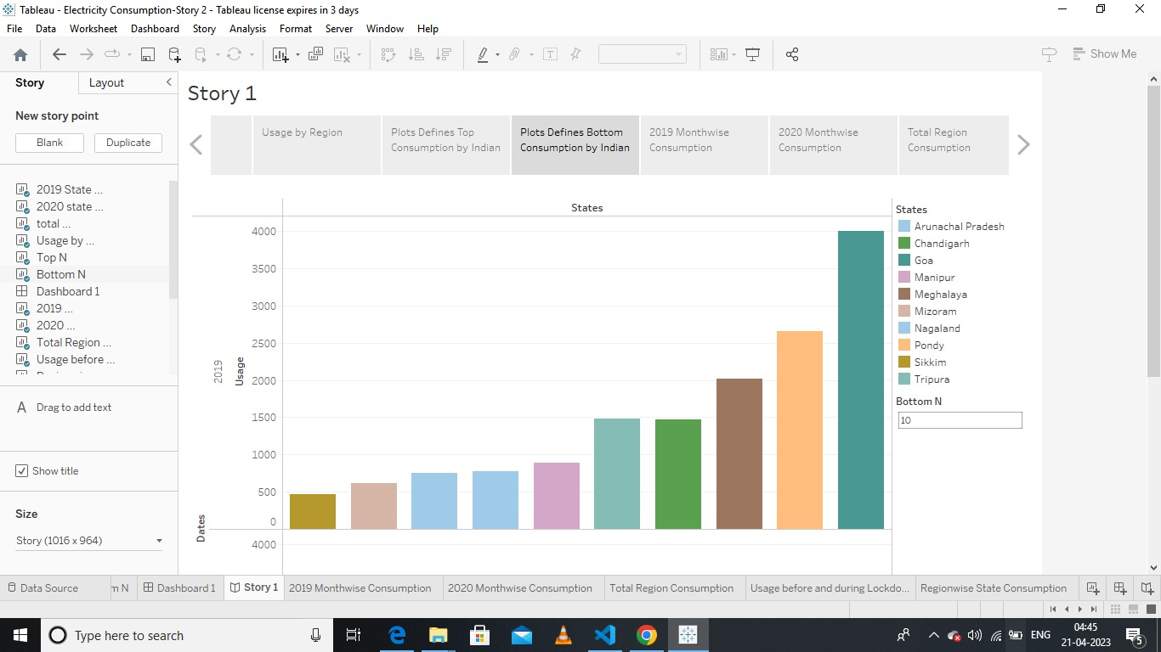

***Fig:3.3.1 Story-Electricity Consumption***

4 ADVANTAGES & DISADVANTAGES

***4.1 ADVANTAGES OF ELECTRICITY CONSUMPTION***

*The advantages of electricity consumption are numerous and are crucial in modern life. Here are some of the key benefits:*

***1. Convenience:*** *Electricity makes modern life possible by powering the devices and tools we use in our homes, offices, and factories. It allows for efficient lighting, heating, cooling, and cooking, among other essential functions. Access to electricity is critical for our comfort and convenience.*

***2. Economic benefits:*** *Electricity powers businesses, fuels industrial production, and enables transportation, creating jobs and driving economic growth. It provides the energy that people need to live and work comfortably, making it a key driver of economic development at both the individual and national levels.*

***3. Sustainability:*** *The use of renewable and sustainable energy sources such as solar, wind, hydro, and geothermal power reduces the carbon footprint of electricity consumption and mitigates climate change. It provides a reliable and inexhaustible source of energy that can be sustainably and ethically sourced.*

***4. Safety:*** *Electricity is a safe and efficient source of energy when properly managed. Electrical wiring and equipment are engineered with safety in mind to prevent fires, shocks, or other accidents.*

***5. Innovation:*** *The demand for electricity has driven innovation and technological advancement in the energy sector, leading to the development of cleaner, more sustainable, and more efficient technologies. As new technologies emerge, they further improve the efficiency and effectiveness of electricity consumption.*

*In summary, electricity consumption brings a wide range of benefits such as convenience, economic prosperity, sustainability, safety, and innovation to modern life. The availability of electricity is essential for a high quality of life, and for the continued growth and prosperity of economies.*

***4.2 DISADVANTAGES OF ELECTRICITY CONSUMPTION***

*While electricity consumption has numerous advantages, there are also some disadvantages that need to be considered. Here are some of the key disadvantages of electricity consumption:*

***1. Pollution and environmental impact:*** *The production of electricity through fossil fuels such as coal, oil, and gas creates significant air and water pollution, contributing to climate change and environmental degradation. Even with the use of renewable energy sources, there is still an impact on the environment, such as the use of land, the production of waste, and the use of resources for renewable energy infrastructure.*

***2. Dependence on non-renewable resources:*** *The majority of electricity production relies on non-renewable resources such as fossil fuels. This dependence leads to fluctuations in price and availability and leaves us vulnerable to supply disruptions, geopolitical conflicts, and other risks.*

***3. Health hazards:*** *Improperly installed or handled electrical equipment can pose significant health risks, such as electrical shock, burns, or fire hazards. Additionally, the environmental impact of mining, processing, and transporting non-renewable resources can pose health hazards to workers and nearby communities.*

***4. Cost:*** *Electricity can be expensive, particularly in developing countries or those where energy infrastructure is outdated, leading to higher costs for businesses, households, and government. These costs might be passed onto consumers, making it difficult for disadvantaged communities to afford access to electricity.*

***5. Energy Security:*** *Reliance on imported fuels can compromise a country's energy security and leave it exposed to price instability, supply interruption, and geopolitical conflicts.*

*In conclusion, while electricity consumption has numerous benefits, it is important to consider the potential environmental, health, and economic impacts. It is imperative for individuals, organizations, and governments to transition to sustainable and alternative energy sources to minimize the disadvantages associated with electricity consumption.*

5 APPLICATION OF ELECTRICITY CONSUMPTION

*Electricity consumption is used in various applications in modern life. Here are some of the key applications:*

***1. Residential:*** *Electricity is used in households and apartments for various purposes, such as lighting systems, heating, cooling, water heating, refrigeration, cooking, and washing clothes. It provides convenience and comfort to homeowners and enhances their quality of life.*

***2. Commercial:*** *Electricity powers businesses and commercial buildings, such as hotels, malls, and offices, for lighting, heating and cooling, power tools, and equipment.*

***3. Industrial:*** *Electricity is an essential energy source for industrial applications such as manufacturing, agriculture processing, oil and gas extraction, mining, and transportation. It powers large machines, equipment, conveyors, and tools used in these processes.*

***4. Transportation:*** *Electricity is becoming an increasingly popular source of energy for electric vehicles, trains, trams, subways, and other modes of transportation. It provides a cleaner and more sustainable alternative to traditional fossil fuel-based vehicles.*

***5. Healthcare:*** *Electricity is key to healthcare applications, including power supply for medical devices such as X-ray machines, CT scanners, ventilators, and dialysis machines.*

***6. Technology:*** *Electricity powers the electronics and communication technologies used in everyday life, such as phones, computers, TVs, radios, and the internet.*

*In summary, electricity consumption has a wide range of applications across various sectors, including residential, commercial, industrial, transportation, healthcare, and technology. The availability of electricity is essential for modern life, society, and economies. As new technologies emerge, these applications will continue to evolve expand, creating new opportunities and benefits for individuals and communities.*

6 CONCLUSION

*Electricity consumption is a fundamental aspect of modern life and plays a critical role in economic growth, social development, and quality of life. The use of electricity enables convenience, comfort, and productivity, as well as the creation of new technologies and industries. However, its production can cause significant environmental and health impacts, and its price and availability can impact economic and social development, particularly in developing countries.*

*To address the challenges associated with electricity consumption, there is an urgent need for a shift towards cleaner and more sustainable sources of energy, improved energy efficiency, and the use of advanced technologies to support smart and resilient grid infrastructure. With continued innovation and investment, it is possible to create a future where accessibility to electricity is widely available and affordable, while also minimizing its impact on the environment and communities.*

*In conclusion, electricity consumption has a significant and positive impact on modern life. While there are challenges associated with its production and consumption, there is great potential for progress in transitioning to cleaner, more sustainable forms of energy, promoting energy efficiency, and safeguarding a greener future for generations to come.*

7 FUTURE SCOPE:

*The future scope of electricity consumption is likely to see a significant shift towards cleaner and more sustainable sources of energy. Here are some of the key areas where changes are expected:*

1. Renewables: *There will be a continued shift towards renewable energy such as wind, solar, hydro, tidal, and geothermal power. These sources of energy do not produce greenhouse gases and are cost-competitive with traditional fossil fuels.*

2. Energy storage: *As renewable energy becomes more pervasive, energy storage systems such as batteries will play a critical role in balancing electricity supply and demand, supporting the use of intermittent renewable energy sources and reducing dependence on grid supplies.*

3. Smart grids*: Advances in digital technologies are enabling the creation of smarter electricity grids, which can integrate new renewable energy sources and technologies, promoting efficiency, reliability, and affordability.*

4. Electric vehicles: *With increasing concerns about climate change and air pollution, there is a growing demand for electric vehicles. The adoption of electric vehicles is expected to reduce greenhouse gas emissions and air pollution.*

5. Energy efficiency: *Improving energy efficiency in buildings, transport, and industrial processes is expected to remain a key priority, reducing demand for energy and minimising greenhouse gas emissions.*

6. Decentralisation: *Smaller scale renewable energy generation will be essential for reducing dependence on fossil fuels and enhancing energy security.*

*In conclusion, the future of electricity consumption is likely to see an increased emphasis on clean and sustainable energy sources, energy storage and smarter grids, with advances in technology supporting increased energy efficiency and the growth of electric vehicles. These developments will help reduce dependence on fossil fuels, mitigate the impacts of climate change, and support a more sustainable and secure energy future.*